**DIS-Asia-China-Mirrors-Warring States-*475 BCE—221 BCE***

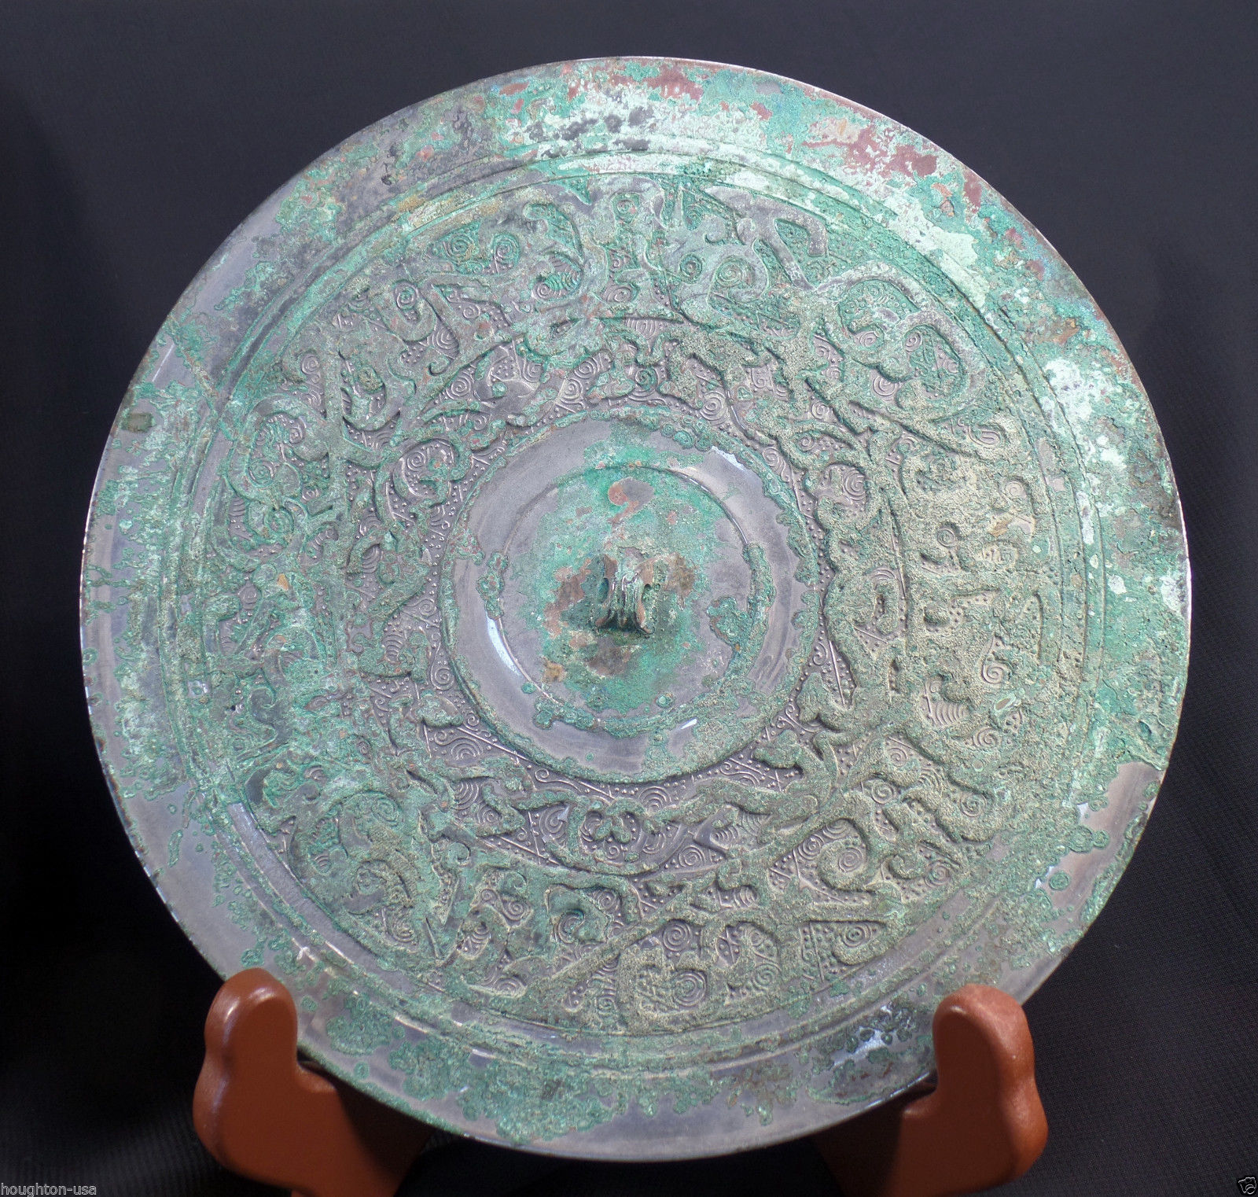

**Ancient, bronze Chinese mirror with an original and authentic patina that dates to about the Warring States Period. This 2,250 year-old bronze mirror measures about 7" (182 mm) diameter and weighs 1.41 lbs. Heavy green bronze oxidation (rust) and erosion on both sides from burial.**

**This ancient Chinese Bronze Mirror is measures about 7” (182 mm) in diameter x .17" (4.3 mm) thick at the rim's edge  and dates approximately to the Warring States Period (475 BC—221 BC).**

**Estimated Value**

**This mirror has an auction appraisal estimate of $10,000--$15,000. At a recent auction at Christie's, a similar but more ornate and larger mirror was estimated to sell between US$60,000-80,000, but the mirror actually sold for $102,500.**

**Mirrors in Ancient China**

**In ancient China, bronze mirrors symbolized good fortune and were thought to protect their owners against evil spirits. Chinese bronze mirrors are usually circular. The Chinese word for "round" (*yuan* 圆) is pronounced the same as the word for "first" (*yuan* 元).  They also have one side highly polished to provide a reflective surface and the other side decorated with an inscription and symbols.**

**Bronze mirrors were produced in China from Neolithic times until the Qing Dynasty, when Western glass mirrors were brought to China. Bronze mirrors were usually circular, with one side polished bright, to give a reflection, and the reverse side with designs. They often had a knob in the center so that they could be attached to clothing.**

**Some of the earliest examples of Chinese bronze mirrors belonged to the Neolithic Qijia culture from around 2,000 BC. However, until Warring States times, bronze mirrors were not common with approximately only twenty having been discovered.**

**During the Warring States period, mirrors became particularly popular. Experts divide the bronze mirrors of the Warring States Period into two categories of the north and the south, according to different decorations. With few decorations, the Northern Bronze Mirrors are plain and small in number, while the Southern Bronze Mirrors are delicate and large in number but with many decorations. This example would be classified as a Northern Bronze Warring States Period Mirror.**

**The smooth, polished side of the mirror still reflects an image despite the green oxidation from the bronze and red oxidation from the tin in the bronze. It was often painted with mercury to provide a lustrous image of the viewer.**

**Iconography**

**One of the peculiarities of the Chinese language is that it has a very large number of written characters, but a much smaller number of spoken sounds. As a result, many Chinese characters share the same pronunciation, i.e. are homonyms.**

**The images cast into ancient, bronze mirrors frequently took advantage of this characteristic. The center knob or “boss” is composed of a coin or embossed circle (smaller than in actual size) with a hole through it in order to suspend it from a cord. A coin (*qian* 钱) can be a visual pun for "before your eyes" because the hole in the center is called an "eye" and the coin (*qian*) has the same pronunciation as the word "before" (*qian* 前). So this mirror reflects the image of the one that holds the coin “before the eyes.”**

**Mirrors may depict animals, plants and other objects to substitute for other words because of their similarity in pronunciation, even though they may not have any other relationship to what is being visualized. So, the pictures of animals on mirrors usually have hidden or implied meaning or a visual pun, and this is what the Chinese refer to as “auspicious or lucky pictures” (*jixiangtuan* 吉祥图 案), i.e., a rebus.**

**Therefore, objects on mirrors such as mythical animals have symbolic meanings because of their similar pronunciation to auspicious Chinese words. On this elaborately cast mirror there are a number of such “auspicious symbols.”**

***Qian***

**Qian or coins make up the center boss, are a potent symbol of wealth and prosperity. The coin--a symbol of wealth--is one of the "Eight Treasures" with a square hole in the middle which reflects the Chinese view of the earth as square and the circular perimeter as the heavens. A coin (qian 钱) can be a visual pun for "before your eyes" because the hole in the center is called an "eye" and the coin (*qian*) has the same pronunciation as the word "before" (*qian* 前). So this mirror reflects the image of the one that holds it “before your eyes.” An old word for coin is quan (泉). A pair of coins is shuang quan (双泉) which has the same pronunciation as "both complete" (shuang quan 双 全).**

***Dragon***

**The dragon (*long* 龙) is one of the twelve animals of the Chinese zodiac and was believed to live in the mountains or in the seas and can fly into the heavens. As beautifully shown on this bronze mirror, conjoined dragons and phoenix represent the union of a man and a woman.**

**Unlike the dragons of Europe, the Chinese dragon symbolizes power, benevolence, prosperity, longevity and the renewal of life. Ancient Chinese believed the dragon brought rain, good harvests and fertility. Dragons could also ward off evil spirits that were thought to inhabit Earth and protect the daily lives of all who displayed the dragon’s image. The dragon represents the male (yang) and is also associated with the East and Spring.**

***Clouds***

**Clouds, sometimes referred to as "auspicious clouds" (xiangyun 祥云), represent the heavens and also "good luck" because the Chinese word for cloud (yun 云) is pronounced the same as yun (运) meaning "luck" or "fortune." Its form often resembles the auspicious shape of the *lingzhi* "fungus of immortality." The cloud is a commonly seen design and when repeated in a pattern symbolizes never-ending fortune. On this mirror, the clouds are depicted as small, twisted circles.**

**CONDITION**

**Museums and modern archeological studies usually use the general term “copper alloy” instead of just the term “bronze” to describe these ancient treasures, as many other elements (such as tin, lead, zinc, iron, and even arsenic) were added to the copper to form different strengths of types of bronze items. Ancient bronze artifacts such as this mirror are probably about 80% copper and 20% tin, while modern bronze is closer to 88% copper and 12% tin.**

**This mirror has an old patina with some signs of oxidation of the two main elements (tin and copper). One interesting property of bronze is that once it has oxidized superficially, an oxide layer of copper carbonate is formed on the surface and essentially protects the object from further damaging corrosion.**